**המחלקה להנדסת חשמל ואלקטרוניקה**

**מערכות לומדות ולמידה עמוקה (31245)**

**Lab 8 report**

|  |  |
| --- | --- |
| פרנסיס עבוד |  |

**Prepared for: Dr. Amer Adler**

**Date: 13/06/2025**

**EX.1:**

Load the following example into Colab: “Transfer learning with a pretrained ConvNet”: <https://www.tensorflow.org/tutorials/images/transfer_learning>

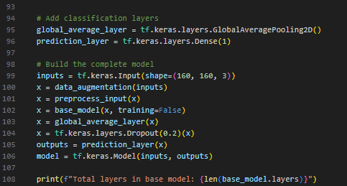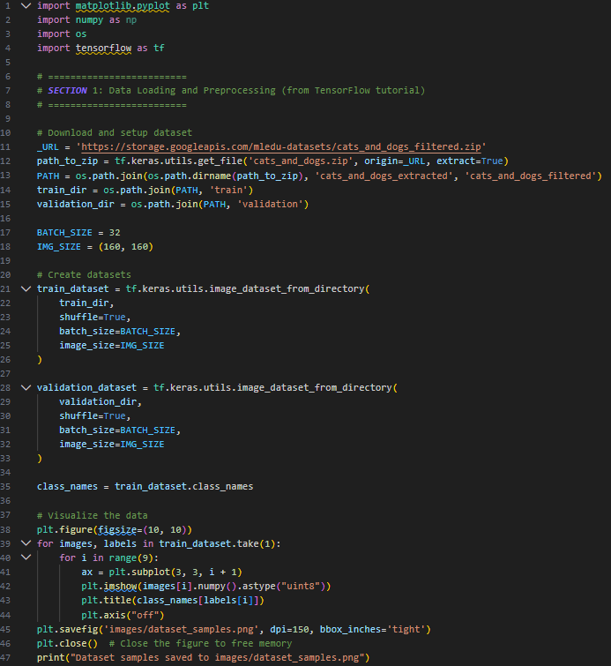**Code:**

**Output:**

* **Dataset sample:**

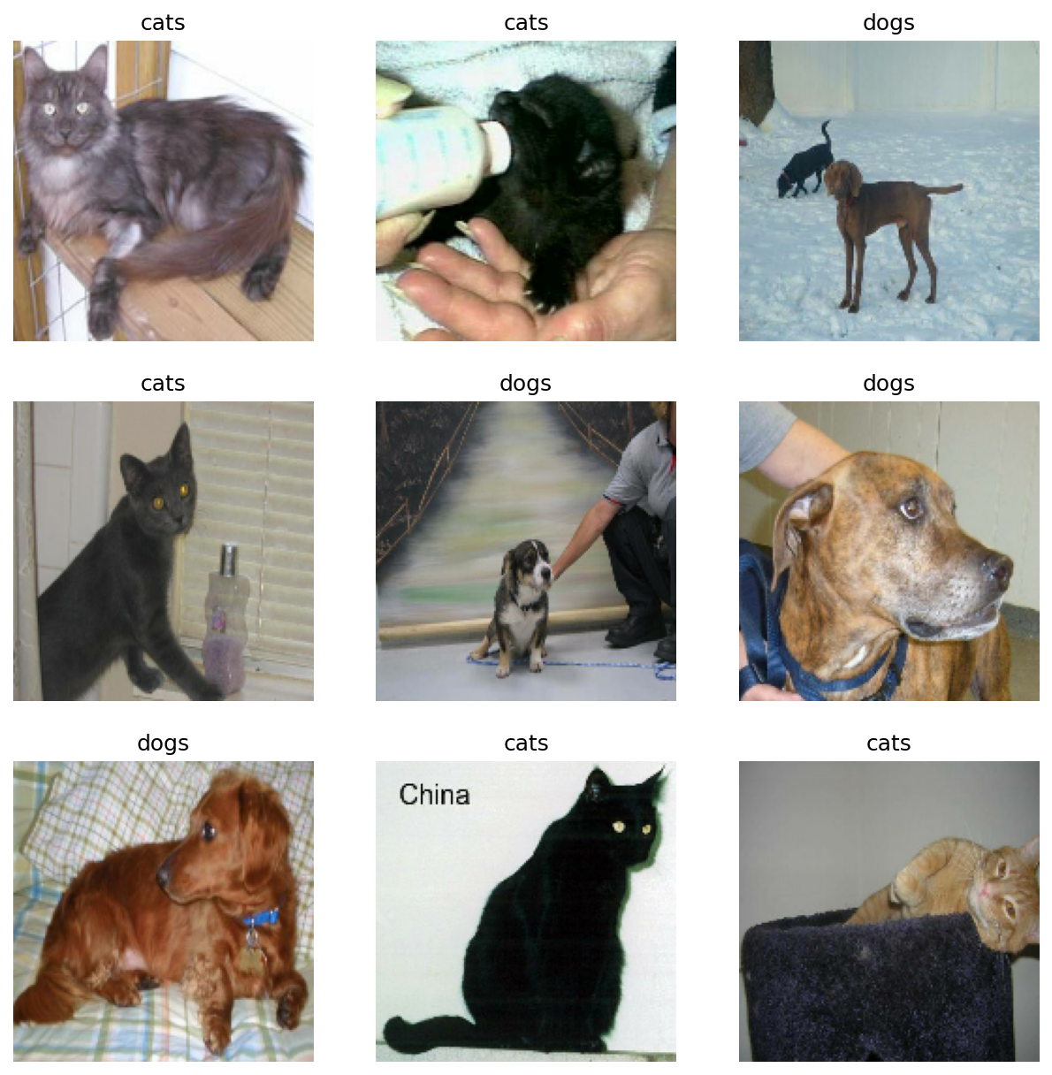

* **Data augmentation:**

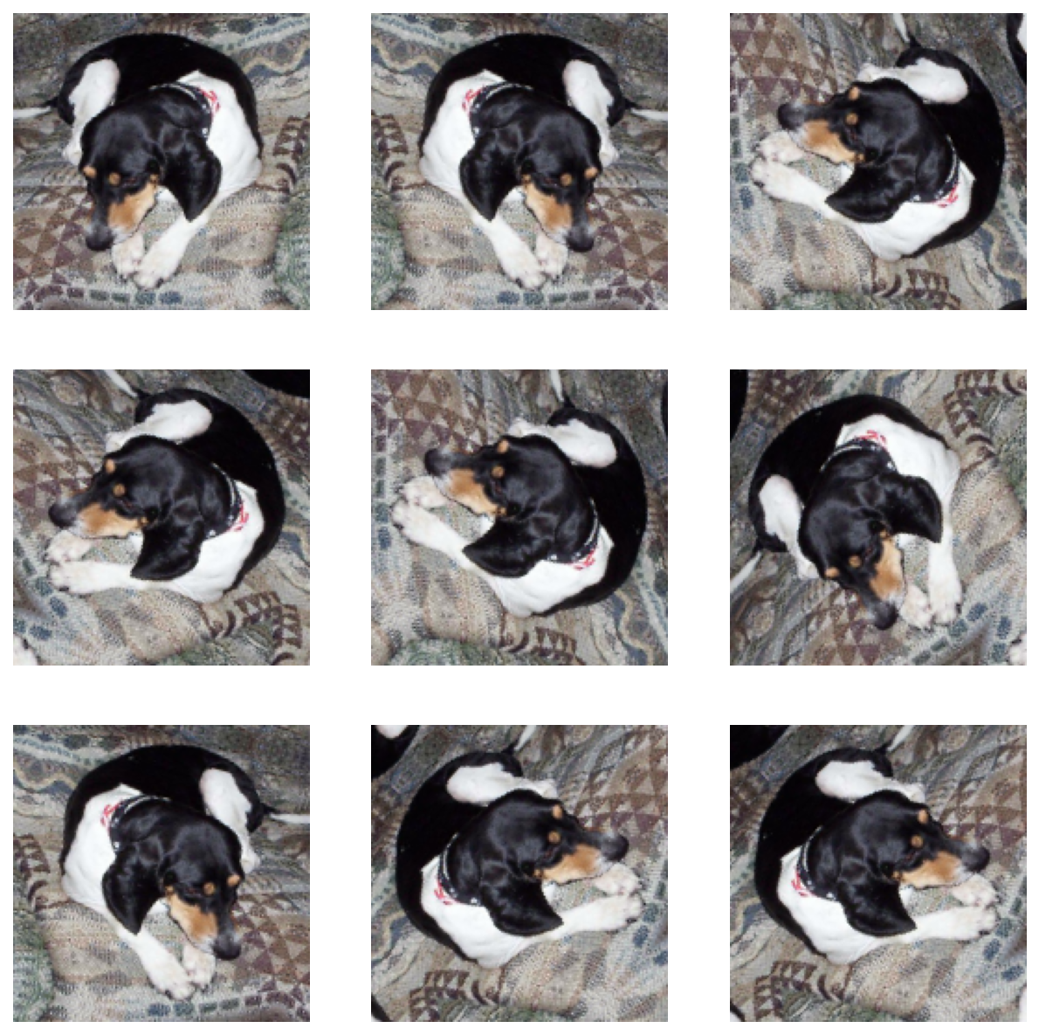

**Ex.2:**

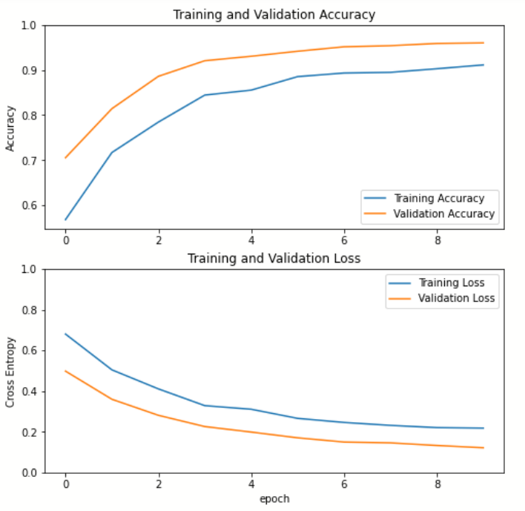Freeze the base CNN layers (MobileNetV2 with 154 layers), and train only the top layers. Provide a loss graph and accuracy graph (vs. epoch number) for 3 different learning rates: 0.01, 0.001, 0.0001 and using SGD, AdaGrad, Adam and RMSprop optimizers. Which learning rate & optimizer provided the best test-set accuracy results?

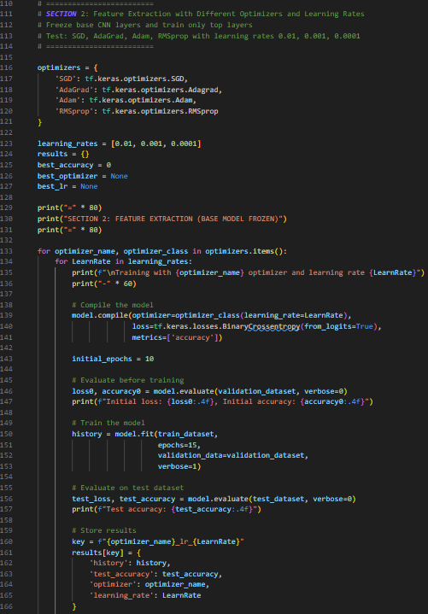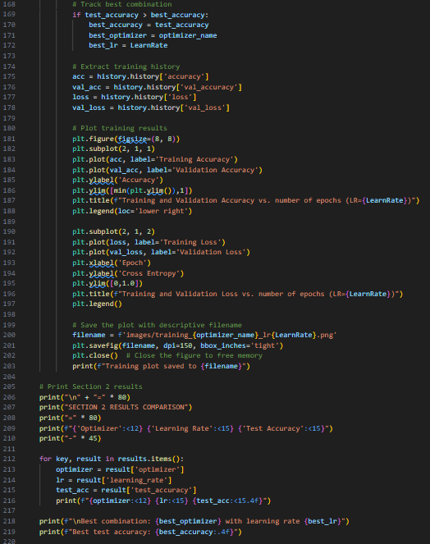**Code:**

**Output:**

* **SGD:**
* **Learning rate set to 0.01:**

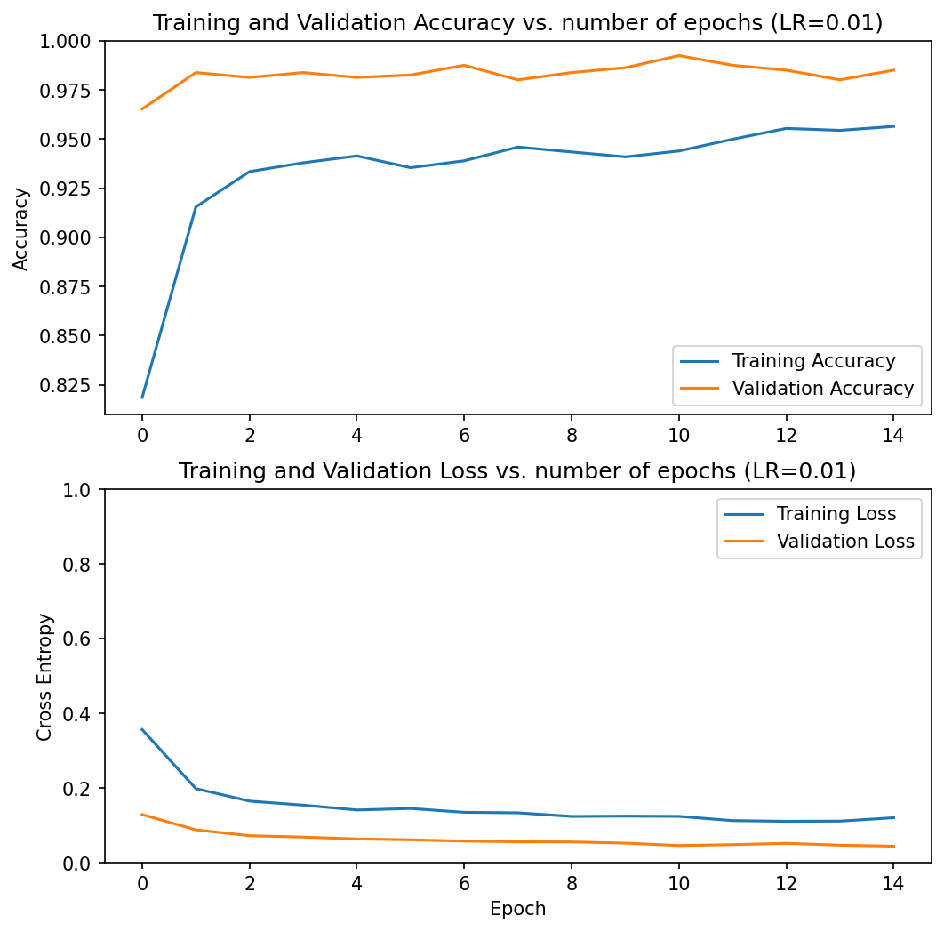 

* **Learning rate set to 0.001:**

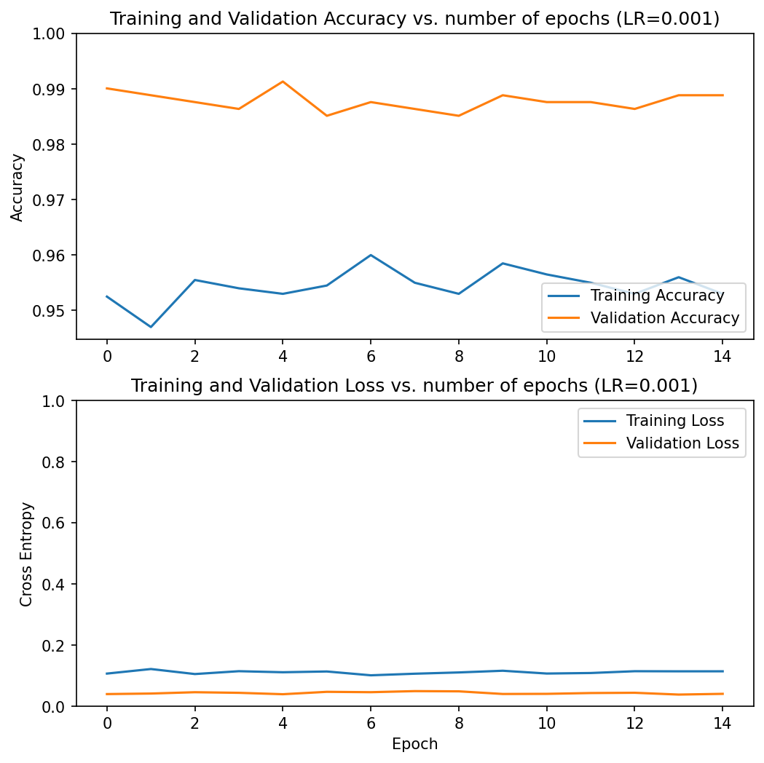

* **Learning rate set to 0.0001:**

****

* **AdaGrad:**
* **Learning rate set to 0.01:**

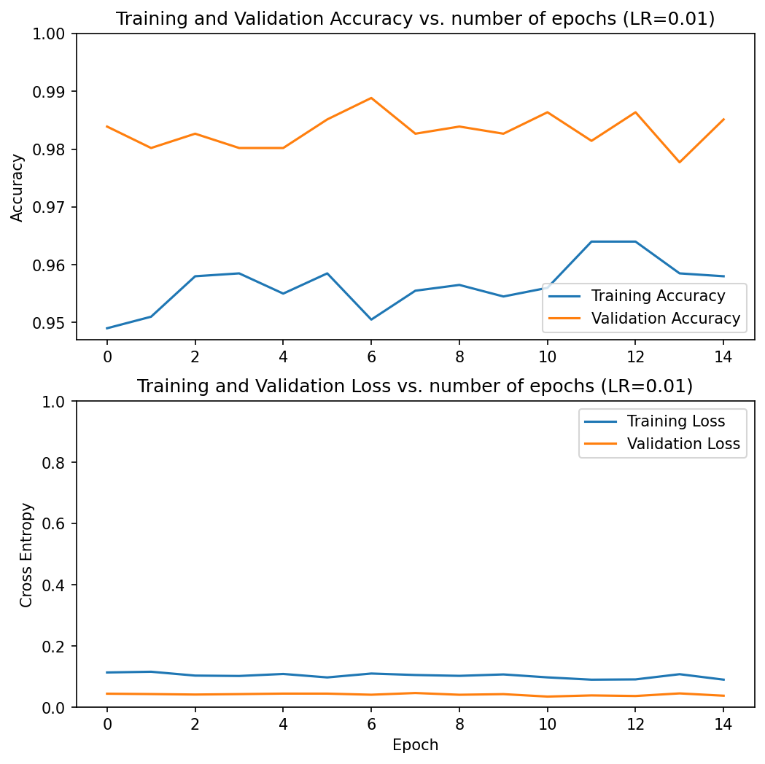

* **Learning rate set to 0.001:**

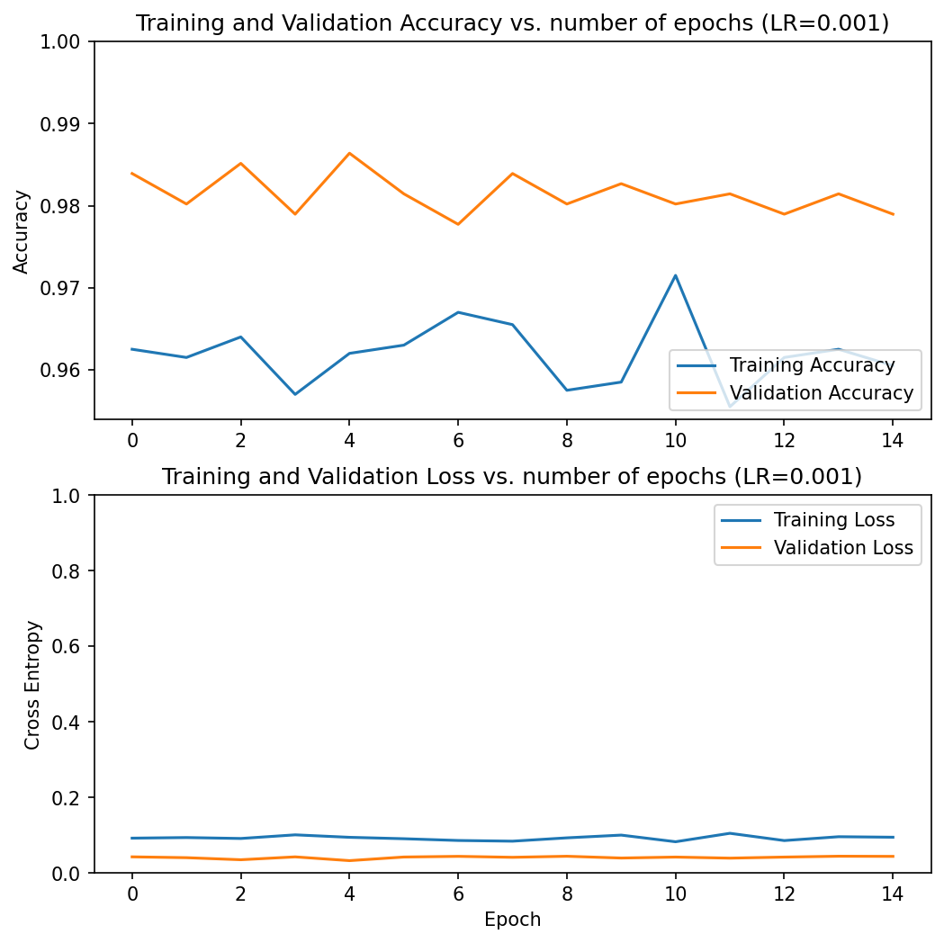

* **Learning rate set to 0.0001:**

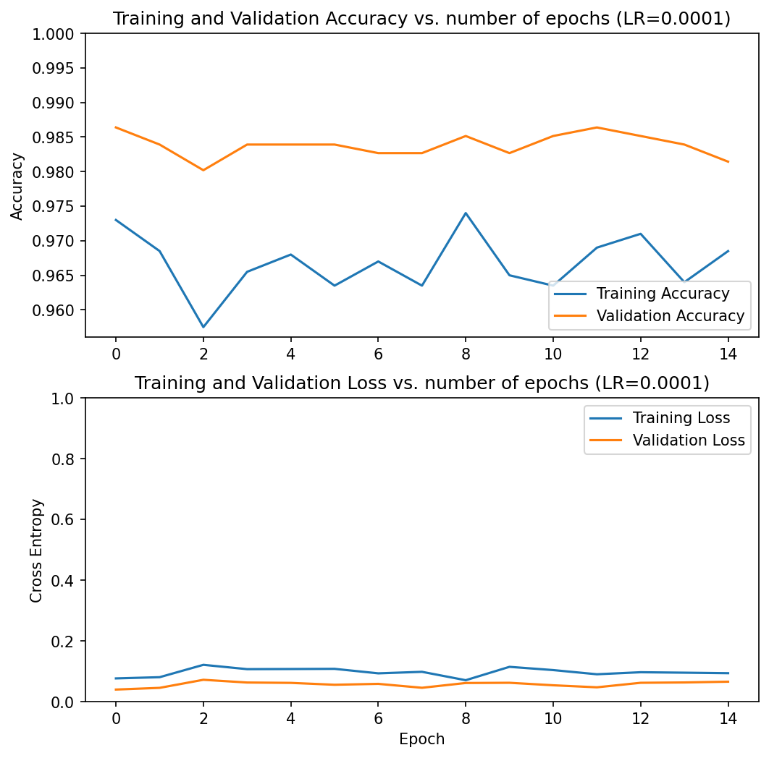

* **Adam:**
* **Learning rate set to 0.01:**



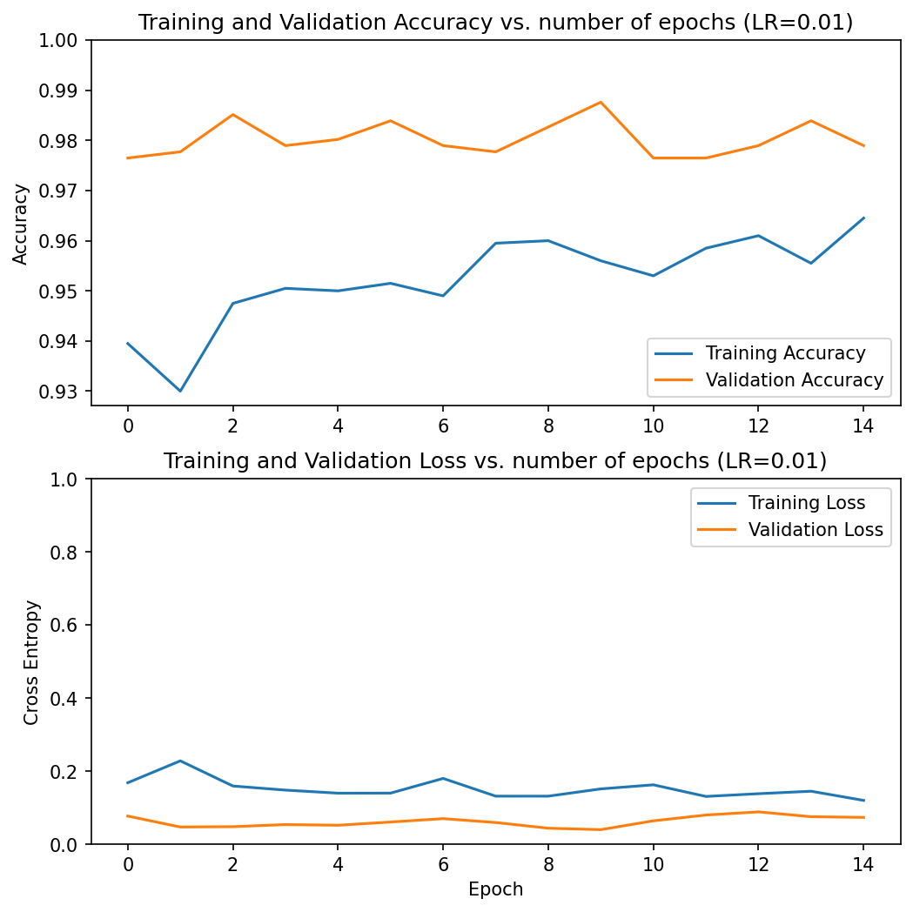

* **Learning rate set to 0.001:**

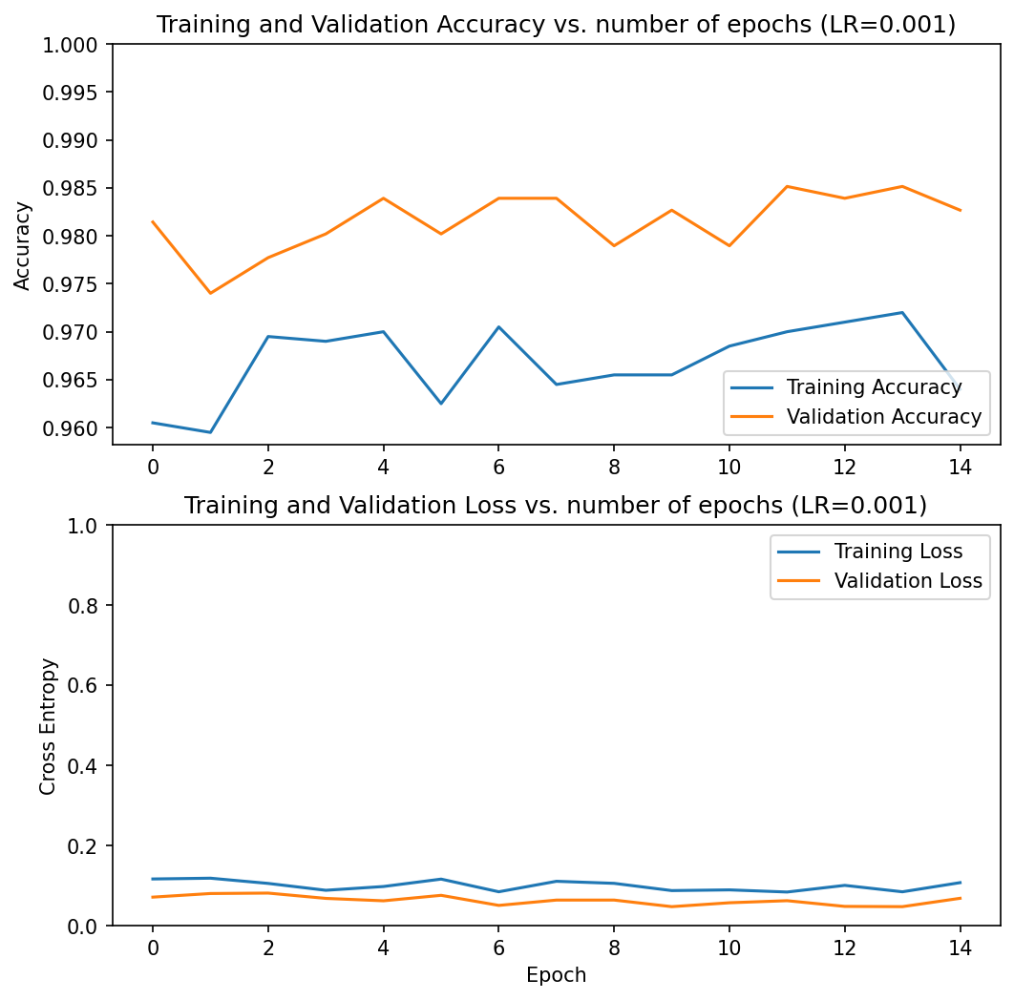

* **Learning rate set to 0.0001:**





* **RMSprop:**
* **Learning rate set to 0.01:**



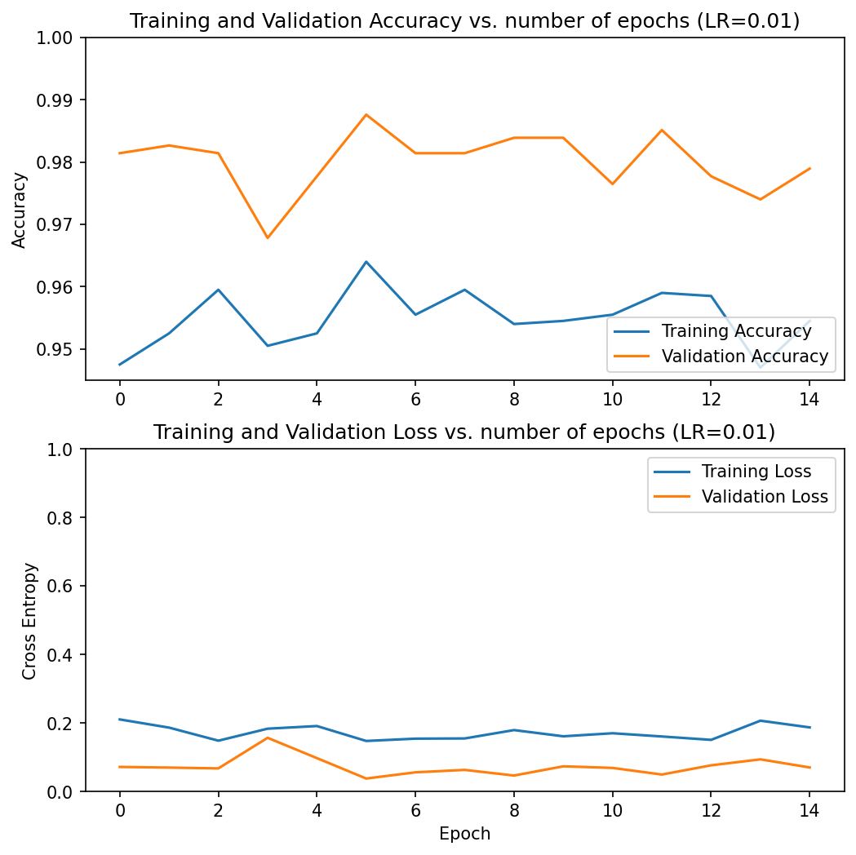

* **Learning rate set to 0.001:**



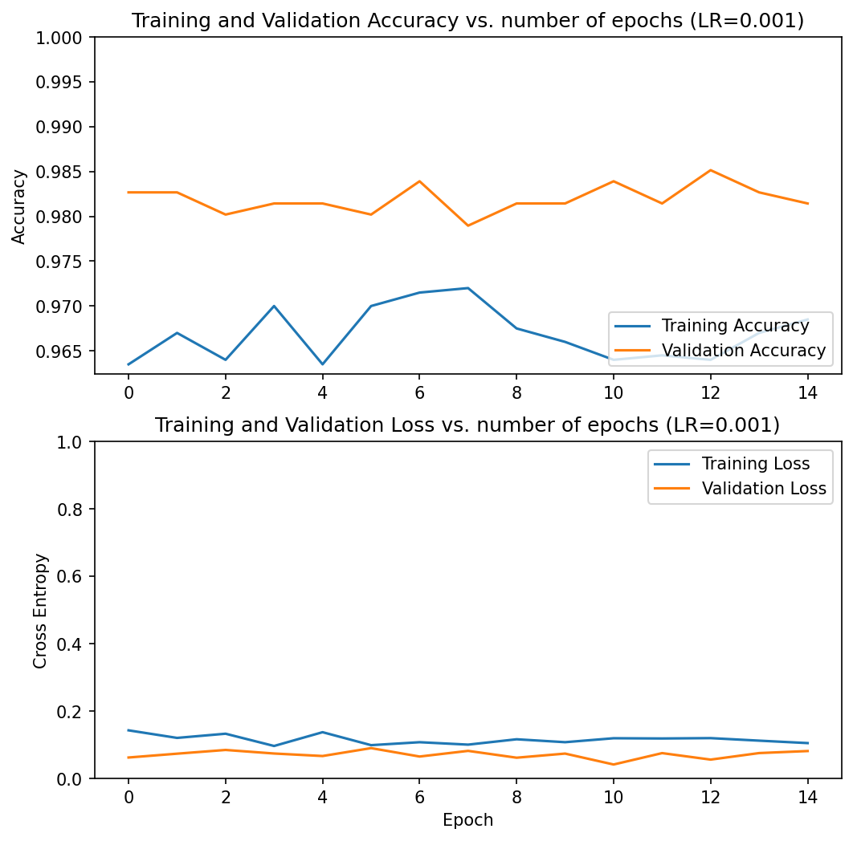

* **Learning rate set to 0.0001:**



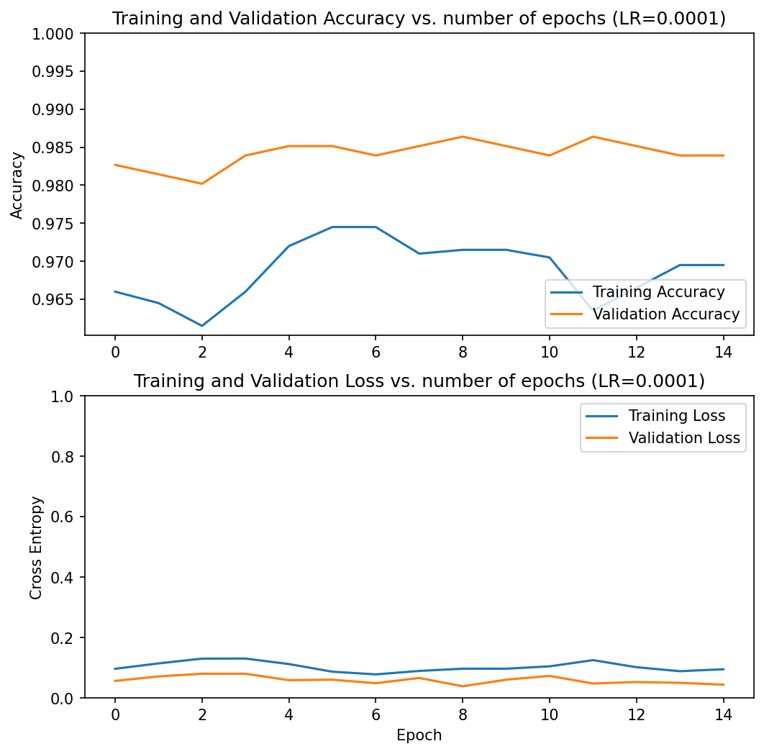

**RESULTS COMPARISON**

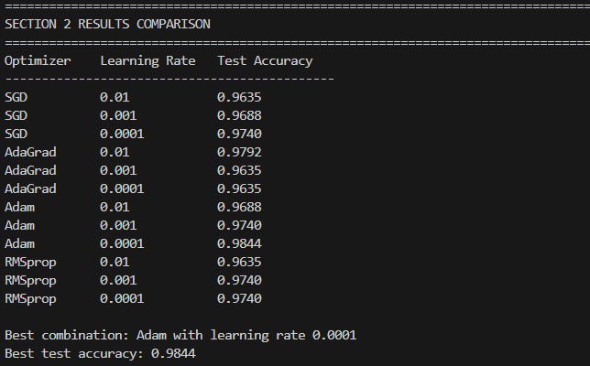

**Ex.3:**

Perform fine-tuning of the base network (starting from layer 100, while layers below 100 are frozen) and the inference layers, using the best optimizer from section 2. Use the learning rates from section 2, after division by 10. Which learning rate provided the best test-set accuracy results?

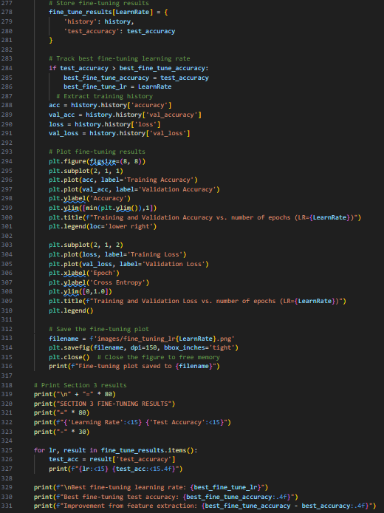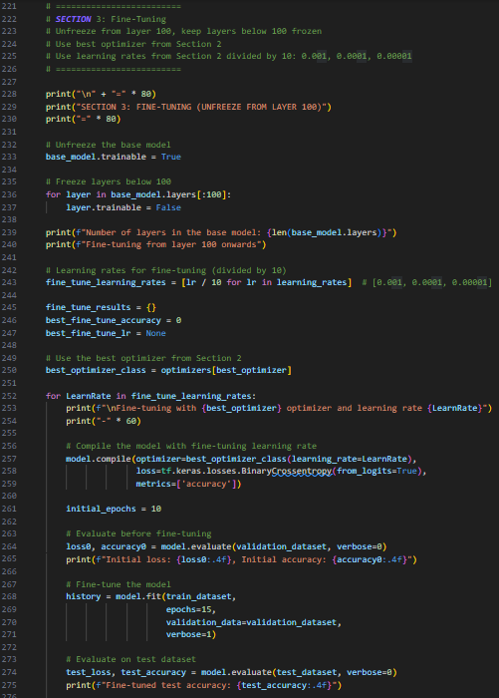**Code:**

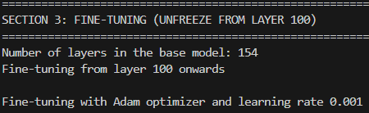**Output:**

* **Learning rate set to 0.001:**



* **Learning rate set to 0.0001:**



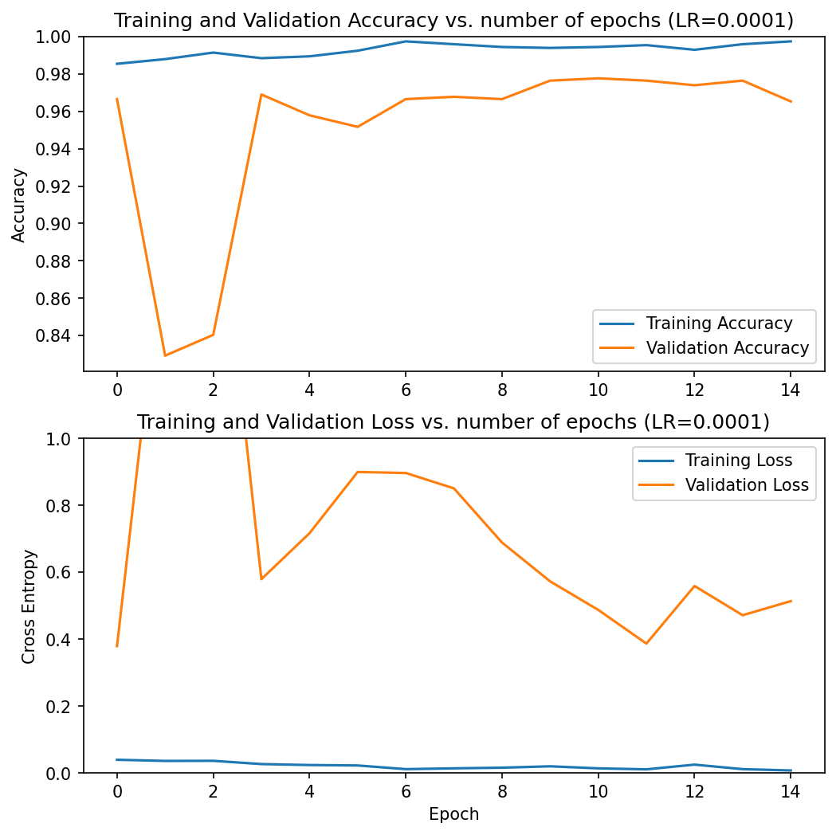

* **Learning rate set to 0.00001:**



**FINE-TUNING RESULTS**

**FINAL SUMMARY**

